**Please note that Jmeter set up was done only in my Local and not in the VM.**

Junit test case which is developed with v4.0 has been extracted as jar file and is deployed in JMeter.

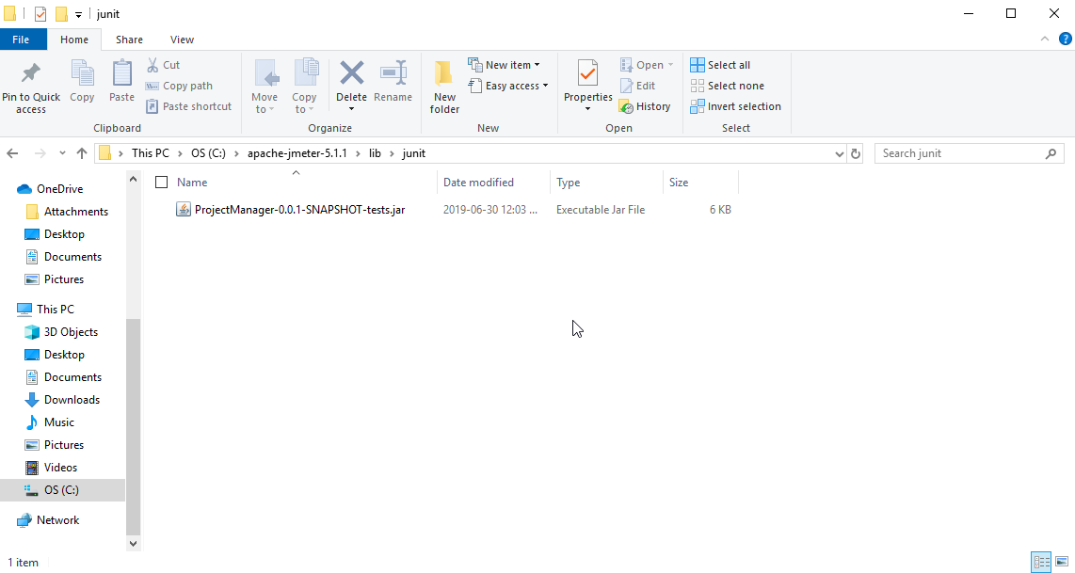

Dependencies are copied to the lib folder.

Jmeter is then configured to execute 500 threads for 10 mins for the test case.

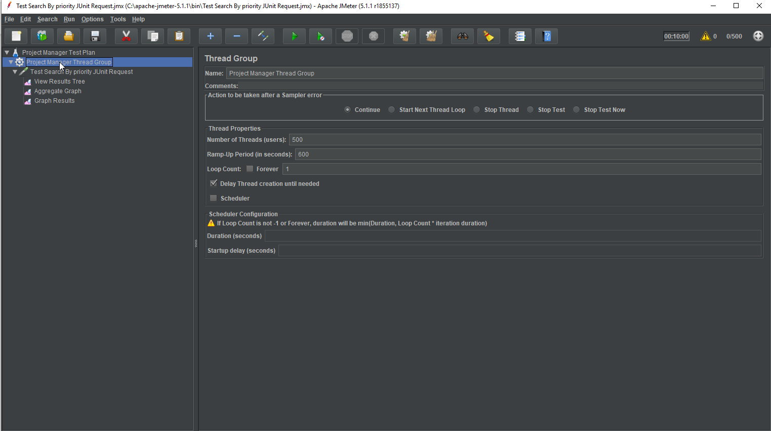

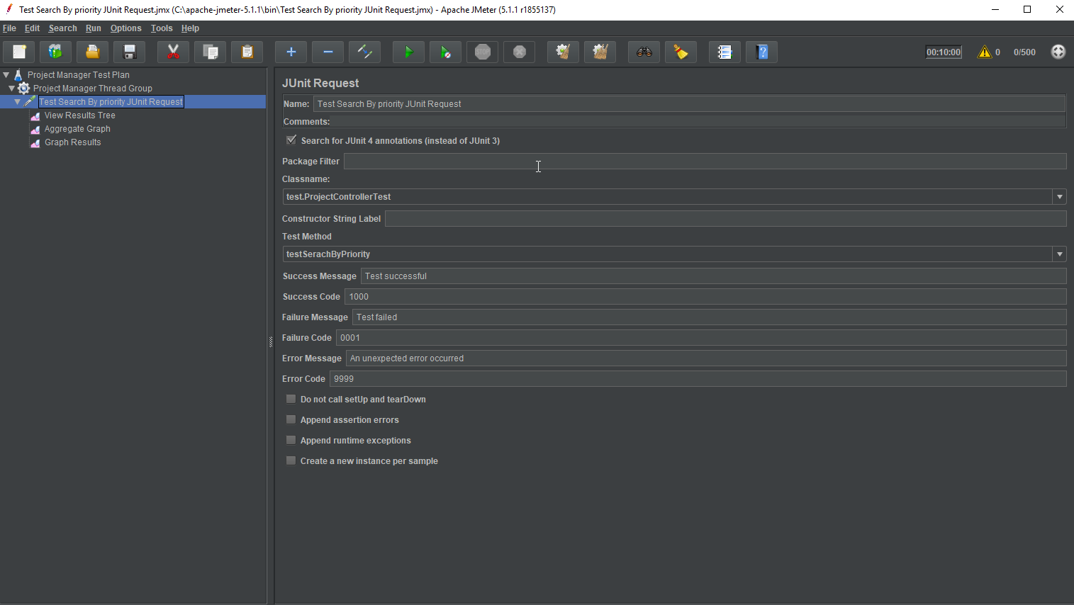

Then the test plan is executed to perform desired load testing. The results are as below.

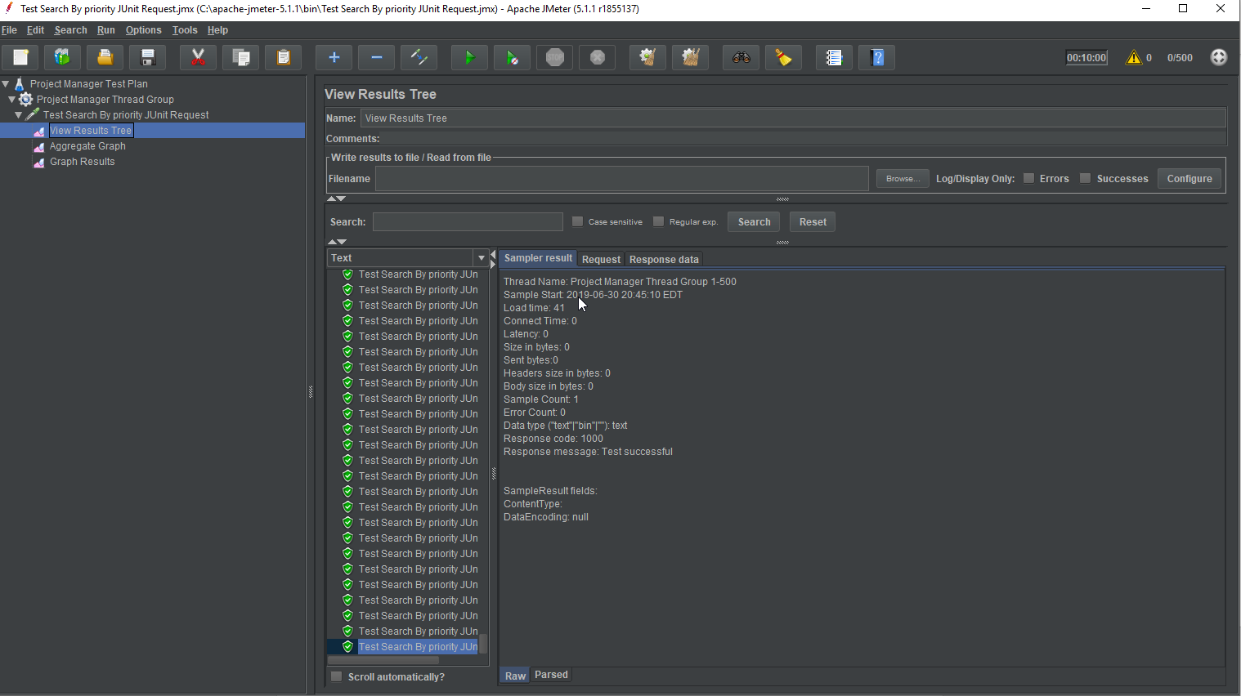

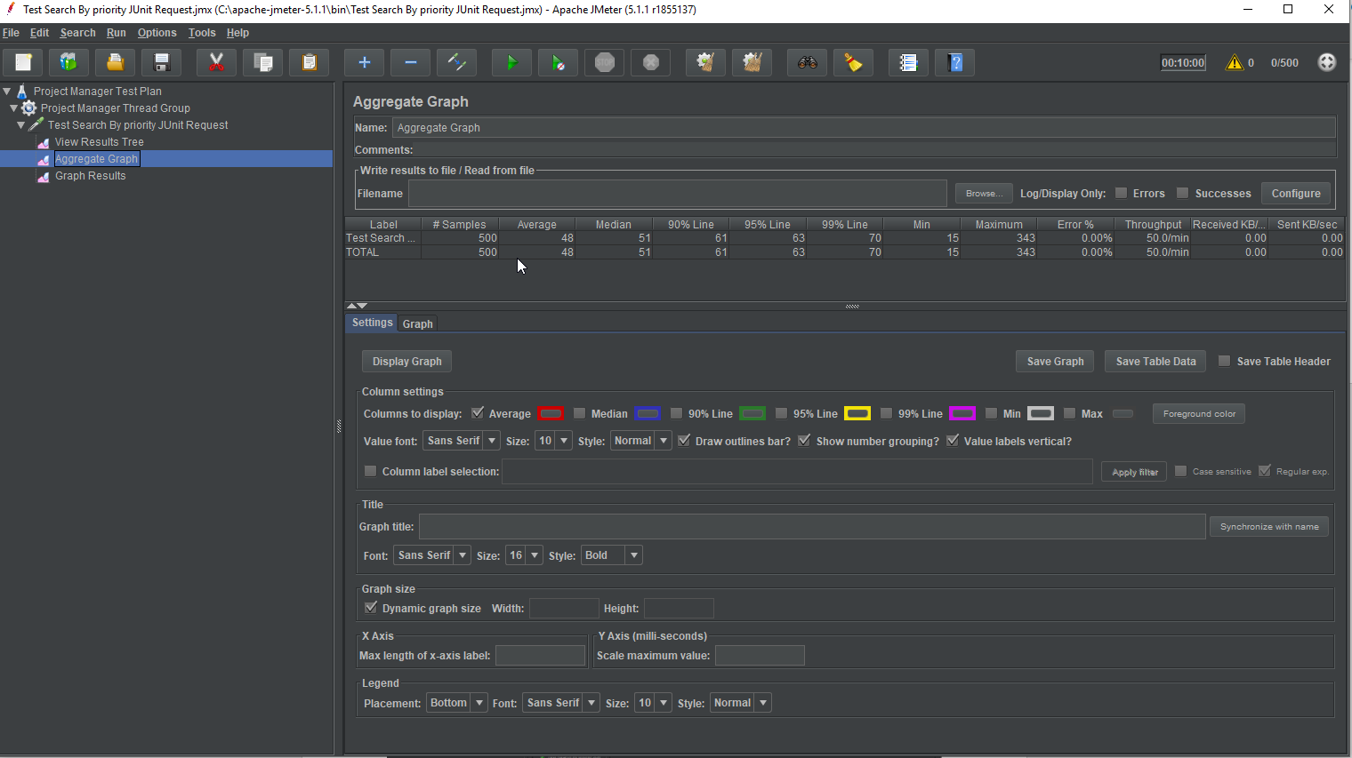

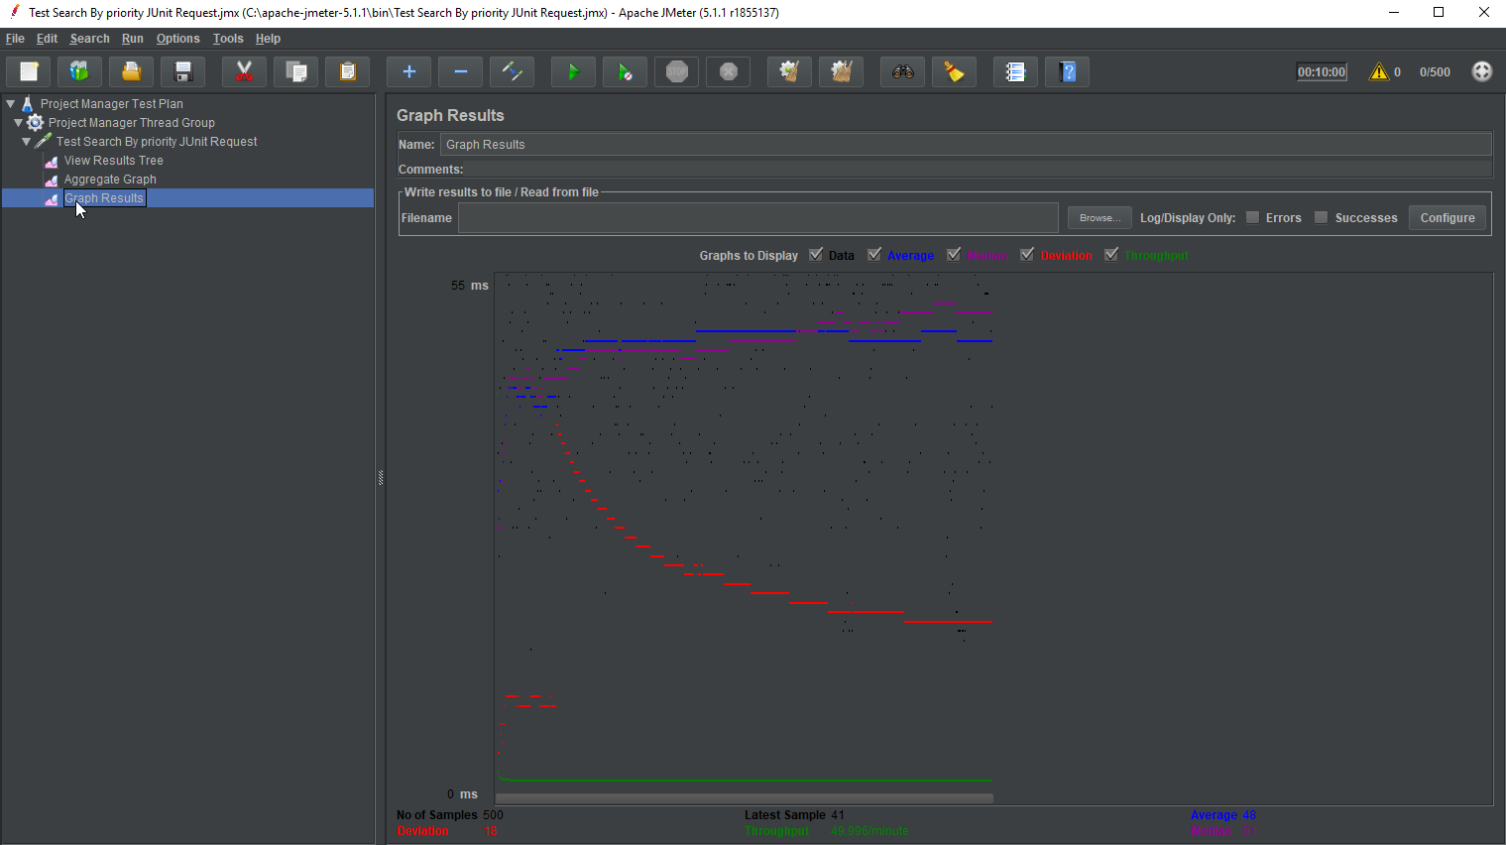

JMX file for one such test method is attached here.

